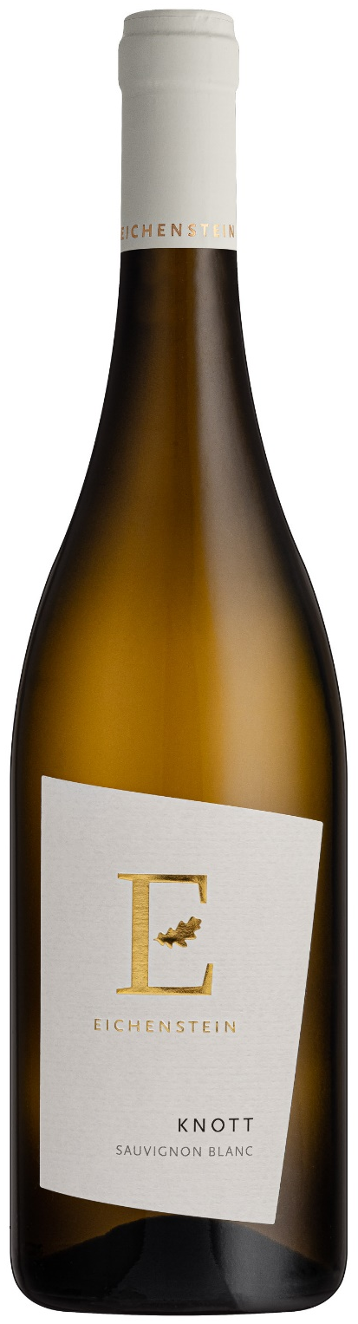
The grapes are picked by hand in the morning. Short maceration on the press and sedimentation in steel tanks. In order to preserve the fresh- ness, fermentation takes place 100% in steel tanks at a temperature of 16-18°C. The later maturation on the fine yeast took place for about 6 months.

Food pairing: Cooked white asparagus and Bolzano sauce, grilled vegetables, grilled white fish and meat

Acidity: 6,2 g/l
Residual sugar: 0,6 g/l
Maturation of the wine: steel tank
Drinking temperature: approx. 12°C
Drinking maturity: 3 -6 years
vinification

Our Sauvignon from the vineyards in Marling is characterized by ele- gant grapefruit, fresh lemon peel and nettle. On the palate a pleasant acidity with deep minerality and a nice drinking flow.

tasting notes

Knott
The grapes for our Sauvignon grow in the Knott vineyard in Marling, at 360 m above sea level. The vineyard, which looks towards Merano, has a slight inclination. The slightly sandy moraine soil consists of granite and slate. Here the vines are pampered and warmed by the morning sun. In the late afternoon the grape zone cools down. This preserves the freshness and the typical Sauvignon taste.

Sauvignon blanc DOC
South tyrol 2024

Yield: 65 hl/ha
Alcohol: 13,5 % Vol.
Variety: 100% Sauvignon Blanc

